Technical Account Manager Questionnaire

# **Name:**

--------------------------------------------------------------------------------------------------------------------------------

## **Tech Section:**

1. Integrate Android/Web on this Account: <https://eu1.dashboard.clevertap.com/KK4-R6K-565Z/my-board.html>

**For web:**

<script type="text/javascript">

var clevertap = {event:[], profile:[], account:[], onUserLogin:[], notifications:[], privacy:[]};

// replace with the CLEVERTAP_ACCOUNT_ID with the actual ACCOUNT ID value from your Dashboard -> Settings page

clevertap.account.push({"id": "TEST-KK4-R6K-565Z"});

clevertap.privacy.push({optOut: false}); //set the flag to true, if the user of the device opts out of sharing their data

clevertap.privacy.push({useIP: false}); //set the flag to true, if the user agrees to share their IP data

(function () {

var wzrk = document.createElement('script');

wzrk.type = 'text/javascript';

wzrk.async = true;

wzrk.src = ('https:' == document.location.protocol ? 'https://d2r1yp2w7bby2u.cloudfront.net' : 'http://static.clevertap.com') + '/js/a.js';

var s = document.getElementsByTagName('script')[0];

s.parentNode.insertBefore(wzrk, s);

})();

</script>

**For android:**

To associate our Android app with our CleverTap account, we will need to add our CleverTap credentials in the AndroidManifest.xml file in our app.

We need to go to the AndroidManifest.xml file in our project navigator.

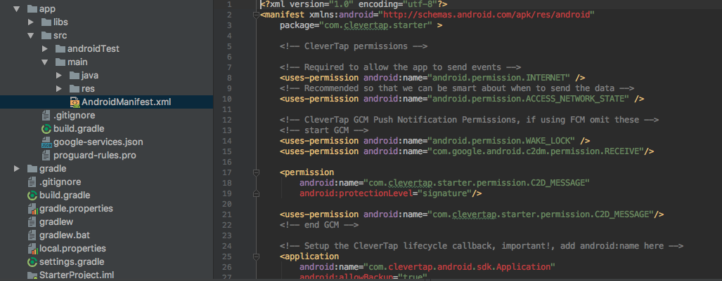

Then we need to add our CleverTap Account ID and Token to our AndroidManifest.xml, within the <application></application> tags.

<meta-data

android:name="CLEVERTAP_ACCOUNT_ID"

android:value="TEST-KK4-R6K-565Z"/>

<meta-data

android:name="CLEVERTAP_TOKEN"

android:value="TEST-362-433"/>

<meta-data

android:name="CLEVERTAP_USE_GOOGLE_AD_ID"

android:value="1"/>

Then we need to Enable Tracking by Adding Permissions:

In our AndroidManifest.xml file, we need to add the following snippet within the <application></application> tags.  
  
<application

android:label="@string/app_name"

android:icon="@drawable/ic_launcher"

android:name="com.clevertap.android.sdk.Application">

Next we need to add the snippet below in the same file, so the CleverTap SDK can access the internet.  
  
<!-- Required to allow the app to send events and user profile information -->

<uses-permission android:name="android.permission.INTERNET"/>

<!-- Recommended so that CleverTap knows when to attempt a network call -->

<uses-permission android:name="android.permission.ACCESS_NETWORK_STATE"/>

Then we need to Initialize the CleverTap SDK

In the onCreate() method of our application’s main activity we need to include the code below. This code will initialize the CleverTap SDK.

CleverTapAPI clevertapDefaultInstance = CleverTapAPI.getDefaultInstance(getApplicationContext());

1. Add a button
2. On Click of the above button push Product Viewed Event, with properties: Product ID = 1 & Product Image = <https://d35fo82fjcw0y8.cloudfront.net/2018/07/26020307/customer-success-clevertap.jpg> & Product Name = CleverTap

import json

import requests

headers = {

'X-CleverTap-Account-Id': 'ACCOUNT_ID',

'X-CleverTap-Passcode': 'PASSCODE',

'Content-Type': 'application/json; charset=utf-8',

}

data = {

"d":

[{

"FBID": "34322423",

"ts": 1468308340,

"type": "event",

"evtName": "Product viewed",

"evtData": {

"Product ID": 1,

"Product Image": "https://d35fo82fjcw0y8.cloudfront.net/2018/07/26020307/customer-success-clevertap.jpg",

"Product Name": "CleverTap"

}

}]

}

response = requests.post('https://api.clevertap.com/1/upload', headers=headers, data=json.dumps(data))

1. Push an Email Id ot the profile on click of the above button - Email = dk+<YOUR EMAIL ID>@clevertap.com - Example: [dk+anirduh@clevertap.com](mailto:dk+anirduh@clevertap.com)

headers = {

'X-CleverTap-Account-Id': 'ACCOUNT_ID',

'X-CleverTap-Passcode': 'PASSCODE',

'Content-Type': 'application/json; charset=utf-8',

}

data = {

"d":

[{

"objectId": "25b08803c1af4e00839f530264dac6f8",

"type": "profile",

"profileData": {

"Email": " dk+anirduh@clevertap.com"

}

}]

}

response = requests.post('https://api.clevertap.com/1/upload', headers=headers, data=json.dumps(data))

1. Integrate Firebase/Web Push Service using these credentials [For android you have to add channel ID “1”]:
   1. Sender ID - 675579704559

Would need access to android studio for App, and GTM for Website to

integrate the same. Web push service enablement and app push notif

enablement would furthermore need FCM/GCM credentials.

1. Write a script in any language to successfully upload the attached CSV as User Profiles

**Dev Docs:**<https://developer.clevertap.com/docs>

**Date Upload** - https://docs.google.com/spreadsheets/d/1HtrazCZxqv7M61g7d2WIvvwLa2U3xywQtpduYo_nnts/edit#gid=0

--------------------------------------------------------------------------------------------------------------------------------

## **Product Section:**

1. Add your own Email Creds on the CleverTap Dashboard with NickName as your Name  
     
   This is done.
2. Create an Email Campaign which goes out to all Users who have viewed the product today where Product ID = 1

Have created a Live segment based journey (Which pushes the email every

time user qualifies upon product view), as well as a broadcast email campaign

FYR.

1. Create a Journey which sends a Push notification to the User as soon as he/she launches the App

Done

1. Create a funnel from App Launched to Product Viewed and bookmark it  
     
   Done

Assumptions: a) Strict order enabled. B) Conversion time assumed to be 1 day as

is typically observed.

Kindly find the same under “Abhishek’s board”

1. Create a segment of Users which were uploaded  
     
   Done

10999 records uploaded.

Identity kept as User_ID assuming it’s unique for every user.

New User Property created as “Reason” with value being: abhishek_test

**User Docs**:<https://docs.clevertap.com/docs>